**1. Download and install the Wireshark software.**

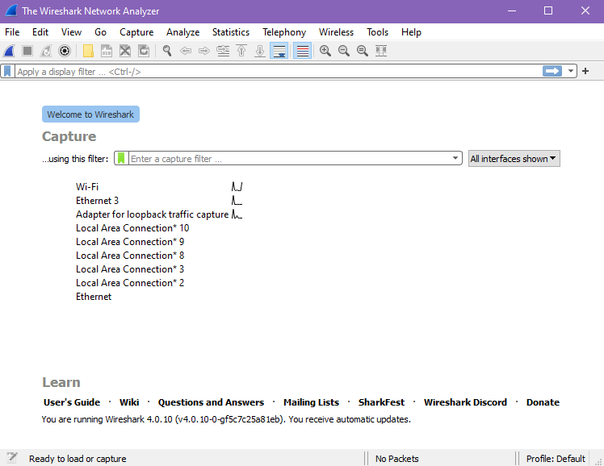

**2. Start capturing packets by selecting one of the interfaces.**

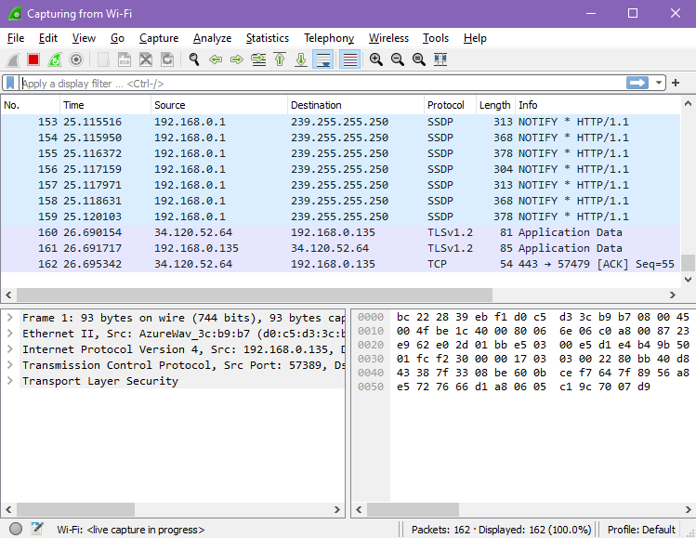

**3. filter 'http/https packets'**

**4. Which version of http is your browser running?**

**5. does the browser indicate the language that it can accept to talk to the server? If yes, then write.**

**6. What is the IP address of your computer?**

**7. What is the request status code returned from the server to your browser? State the meaning of the code returned.**

**8. How many bytes of content are being returned to your browser?**